**Computer Organization and Assembly Language**

|  |  |
| --- | --- |
| **Lab 1** | |
| **Topic** | 1. Introduction to Memory and registers |

**Types of Registers:-**

The registers are grouped into three categories:-

1. **General Purpose registers**
   1. *Data registers*
      1. ***AX*** is the primary accumulator.
      2. ***BX*** is known as the base register.
      3. ***CX*** is known as the count register.
      4. ***DX*** is known as the data register.
   2. *Pointer registers*
      1. Instruction Pointer ***IP***
      2. Stack Pointer ***SP***
      3. Base Pointer ***BP***
   3. *Index registers*
      1. Source Index ***SI***
      2. Destination Index ***DI***
2. **Control registers**
   1. Instruction Pointer and Flag register
3. **Segment registers**
   1. Code Segment ***CS***
   2. Data Segment ***DS***
   3. Stack Segment ***SS***
   4. Extra Segment ***ES***

**Types of variables**

|  |  |  |
| --- | --- | --- |
| **Type** | **No. of bits** | **Example declaration:** |
| Byte | 8 | Num1: db 43 |
| Word=> 2 bytes | 16 | Num2: dw 0xABFF |
| double word=> 2 words | 32 | Num3: dd 0xABCDEF56 |

Note: size of both operands must be same for any type of instruction.

For example:

Mov ax,dh ;is wrong because destination is 2 bytes and source is 1 byte.

***Viewing memory in DOSBOX***

Areas highlighted in red( memory 1) “m1” and blue (memory 2) “m2” are showing the memory contents. *Note:* Two copies of the same memory is displayed in the given windows.

Area highlighted with yellow is showing the ascii values of the contents displayed in the memory m2.

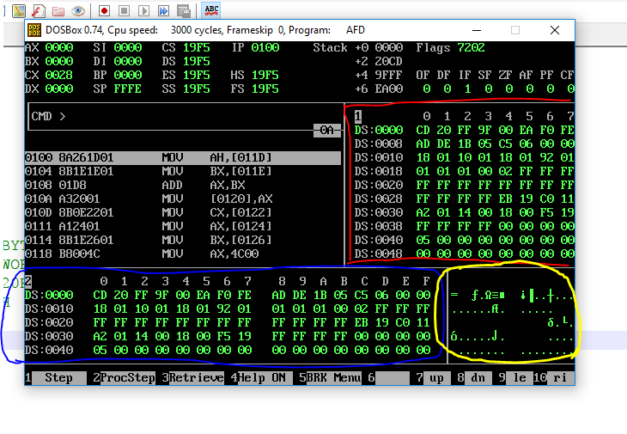

***Viewing sample variable in memory.***

* To view memory from window m2 run the command “m2 ds:***Addressofvariable***” example: m2 ds:011F
* A variable with name “num1” is initialized at memory location 11F with value 65 decimal.

41 hex = 65 decimal is the ascii of “A”.

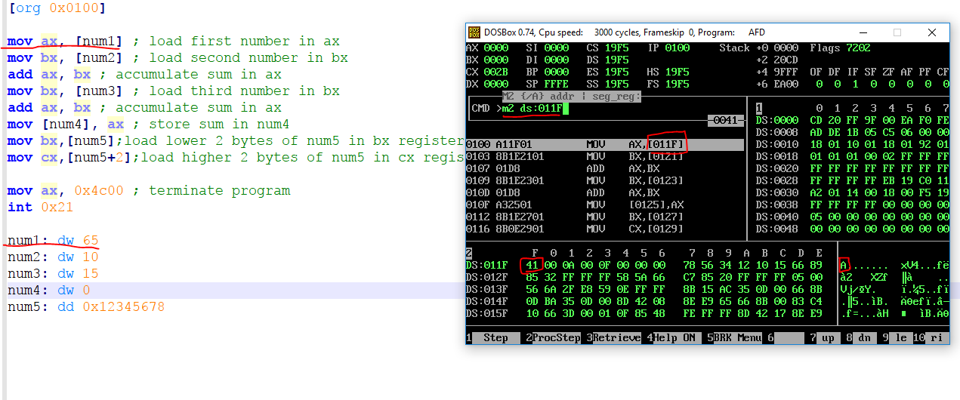

SAMPLE CODE

;a program to add three numbers using memory variables

[org 0x0100]

mov ax, [num1] ; load first number in ax

mov bx, [num2] ; load second number in bx

add ax, bx ; accumulate sum in ax

mov bx, [num3] ; load third number in bx

add ax, bx ; accumulate sum in ax

mov [num4], ax ; store sum in num4

mov ax, 0x4c00 ; terminate program

int 0x21

num1: dw 65

num2: dw 10

num3: dw 15

num4: dw 0

; a program to read double word variable

mov bx,[num5];load lower 2 bytes of num5 in bx register.

mov cx,[num5+2];load higher 2 bytes of num5 in cx register.

num5: dd 0x12345678

mov ax, 0x4c00 ; terminate program

int 0x21

Graded Tasks

1. Write a program with 5 variables of byte size in memory with following values 10, 20,30,40,50.

A=10

B=20

C=30

D=40

E=50

Now solve this expression.

C= (A+B-C) + (E+(A-D)) + (C+B)